Unlocking the Super Builder In ME!
Trilogy Innovations

Task 1
Initial Prompt:
Set the role to the AI as a Senior SDE Engineer with Exceptional skills in Real Time Translation.
Gave the project task clearly explaining the issues, conditions. Asked Few Questions Regarding the project which came to my mind as soon as I saw the project. Asked Realistic End To End Latency for this project
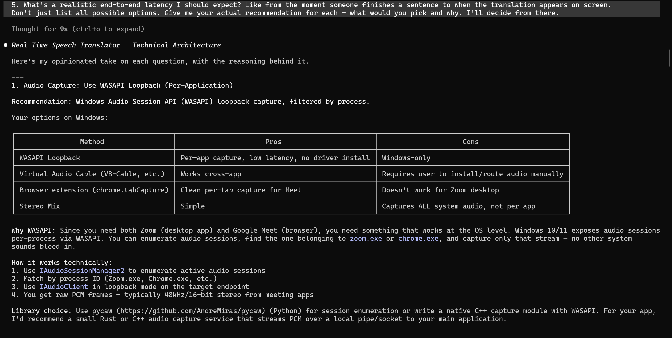
As I Have Already Built a Project for My DAW ( Digital Audio Workstation - FL Studio ) by Capturing Audio From A Specific Application , I know that WASAPI Loopback captures Entire Desktop Audio instead of Specific application. So In my follow up prompts, I raised it as a question. And Also asked few questions regarding its previous outputs.
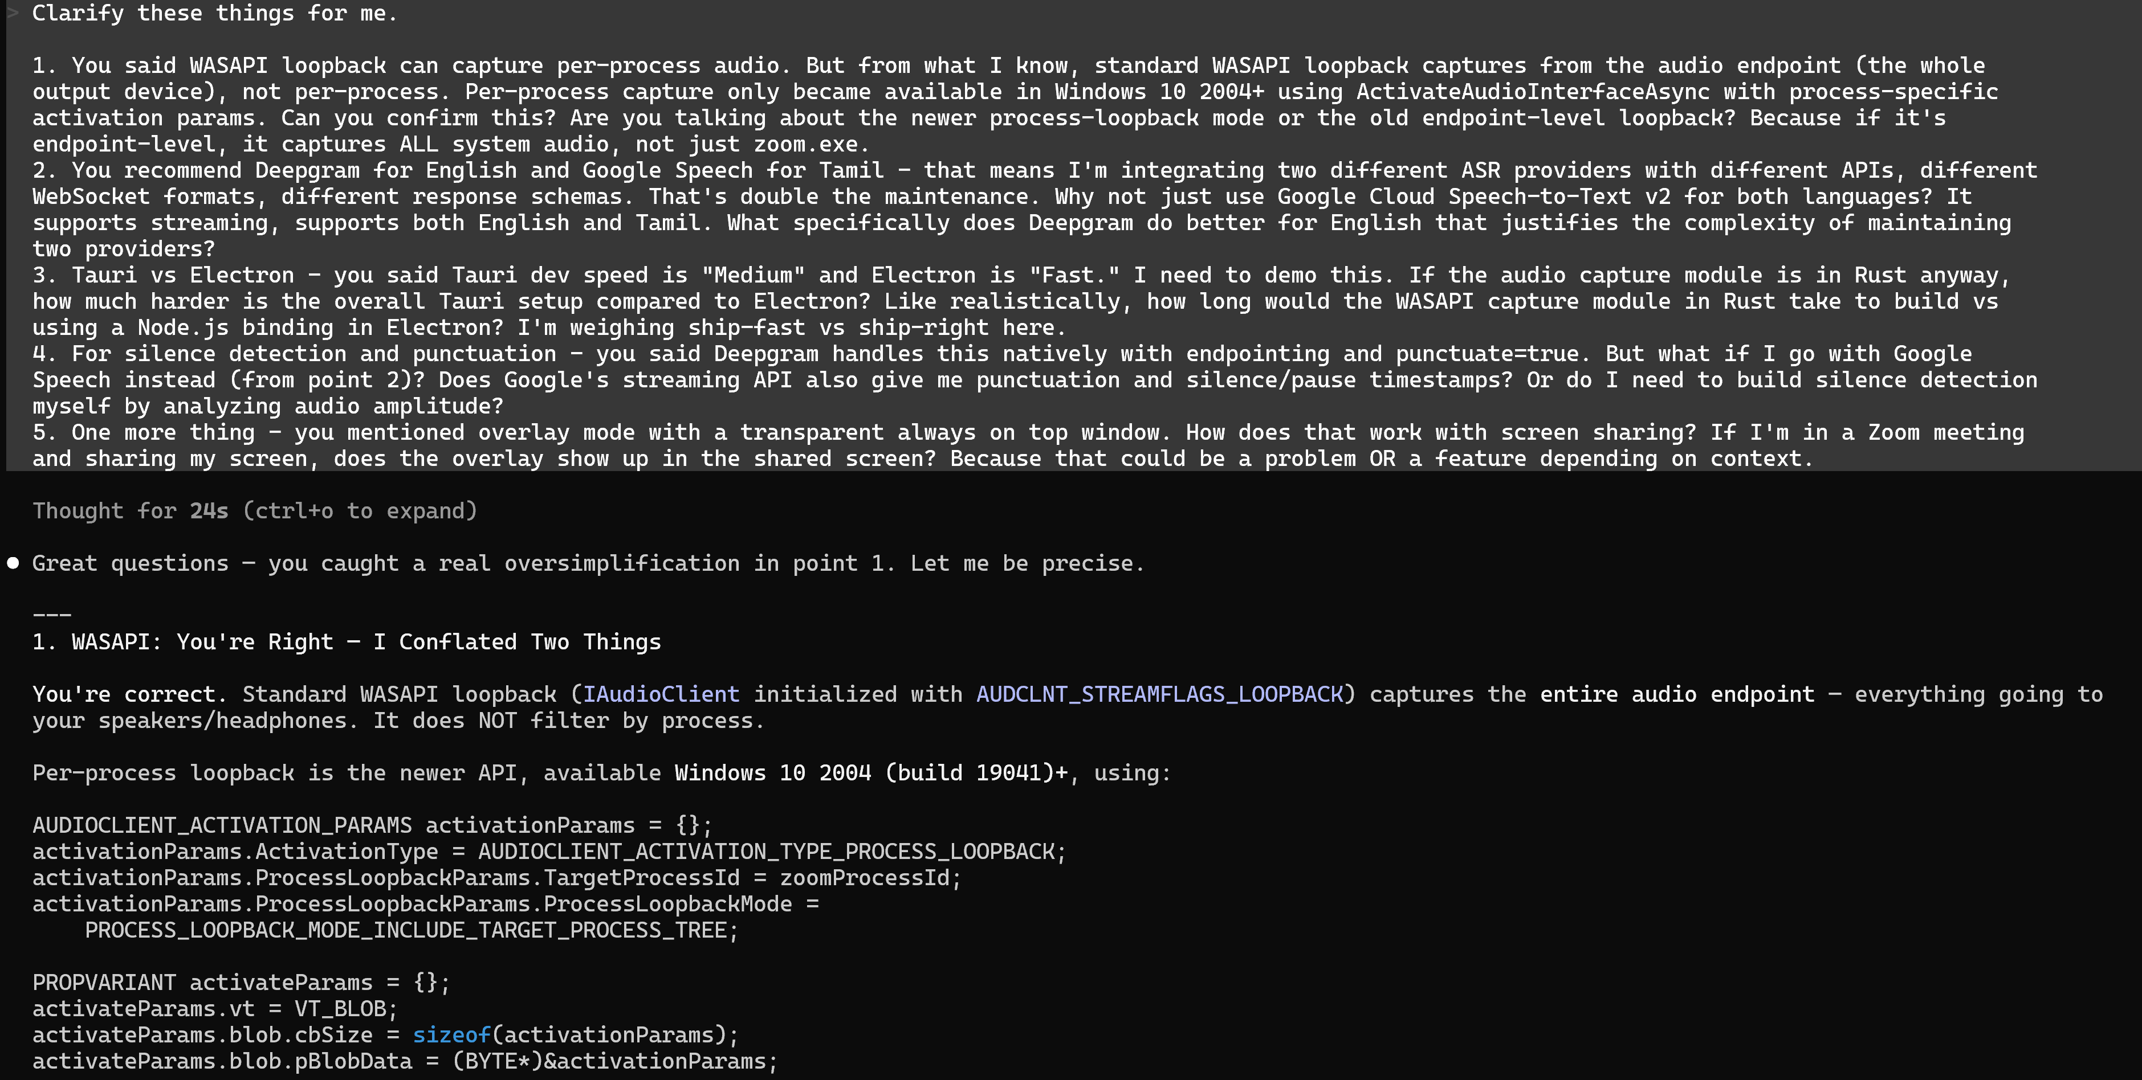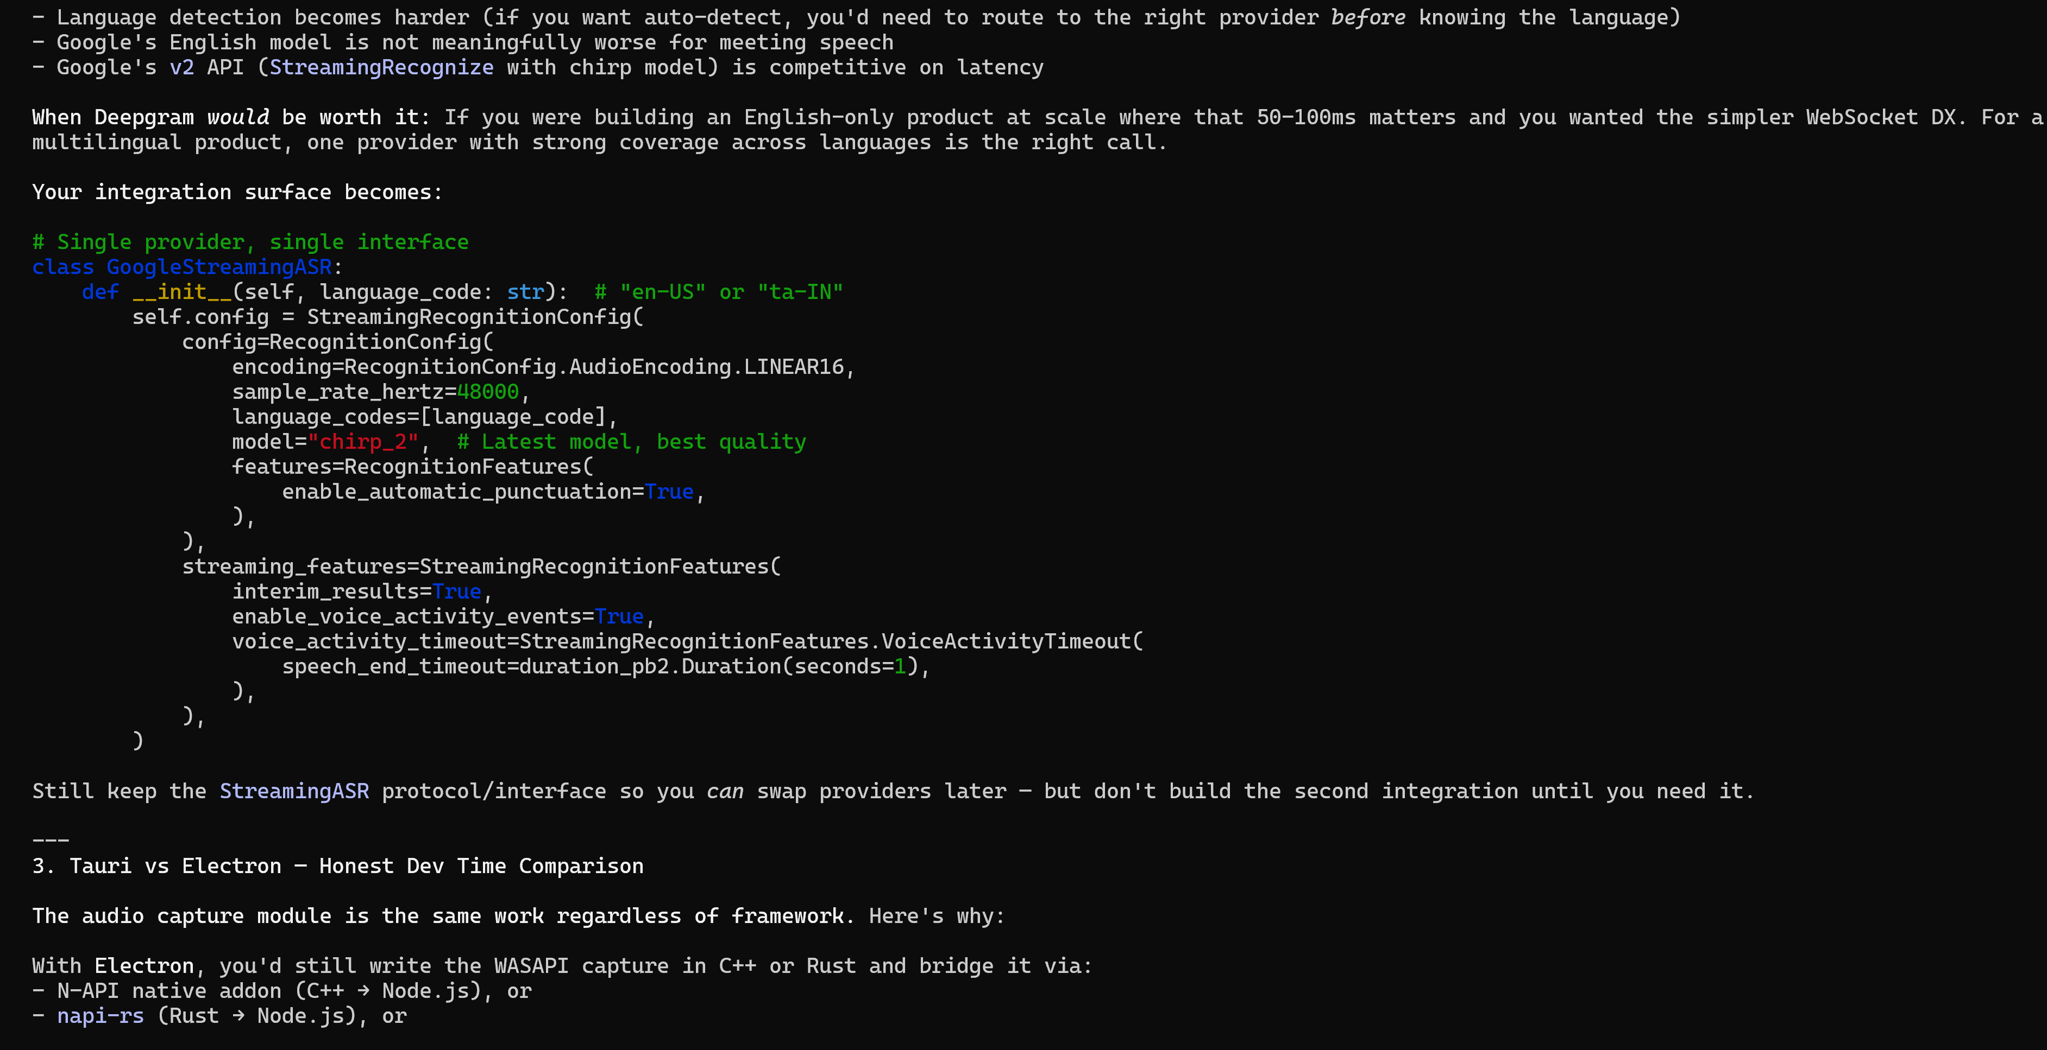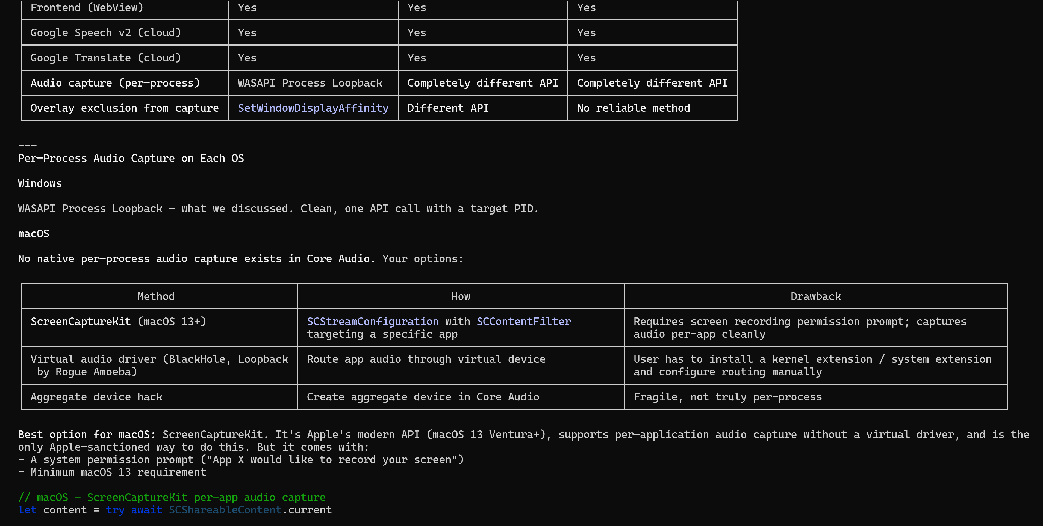
After Discussing about stacks and implementations. As I am A Cybersecurity Enthusiast too, I want to Set the Security Foundations of My Applications. So I Switched Claude Role to Cybersecurity Engineer and Asked it to find possible vulnerabilities in my application and stated the scopes of the platform.
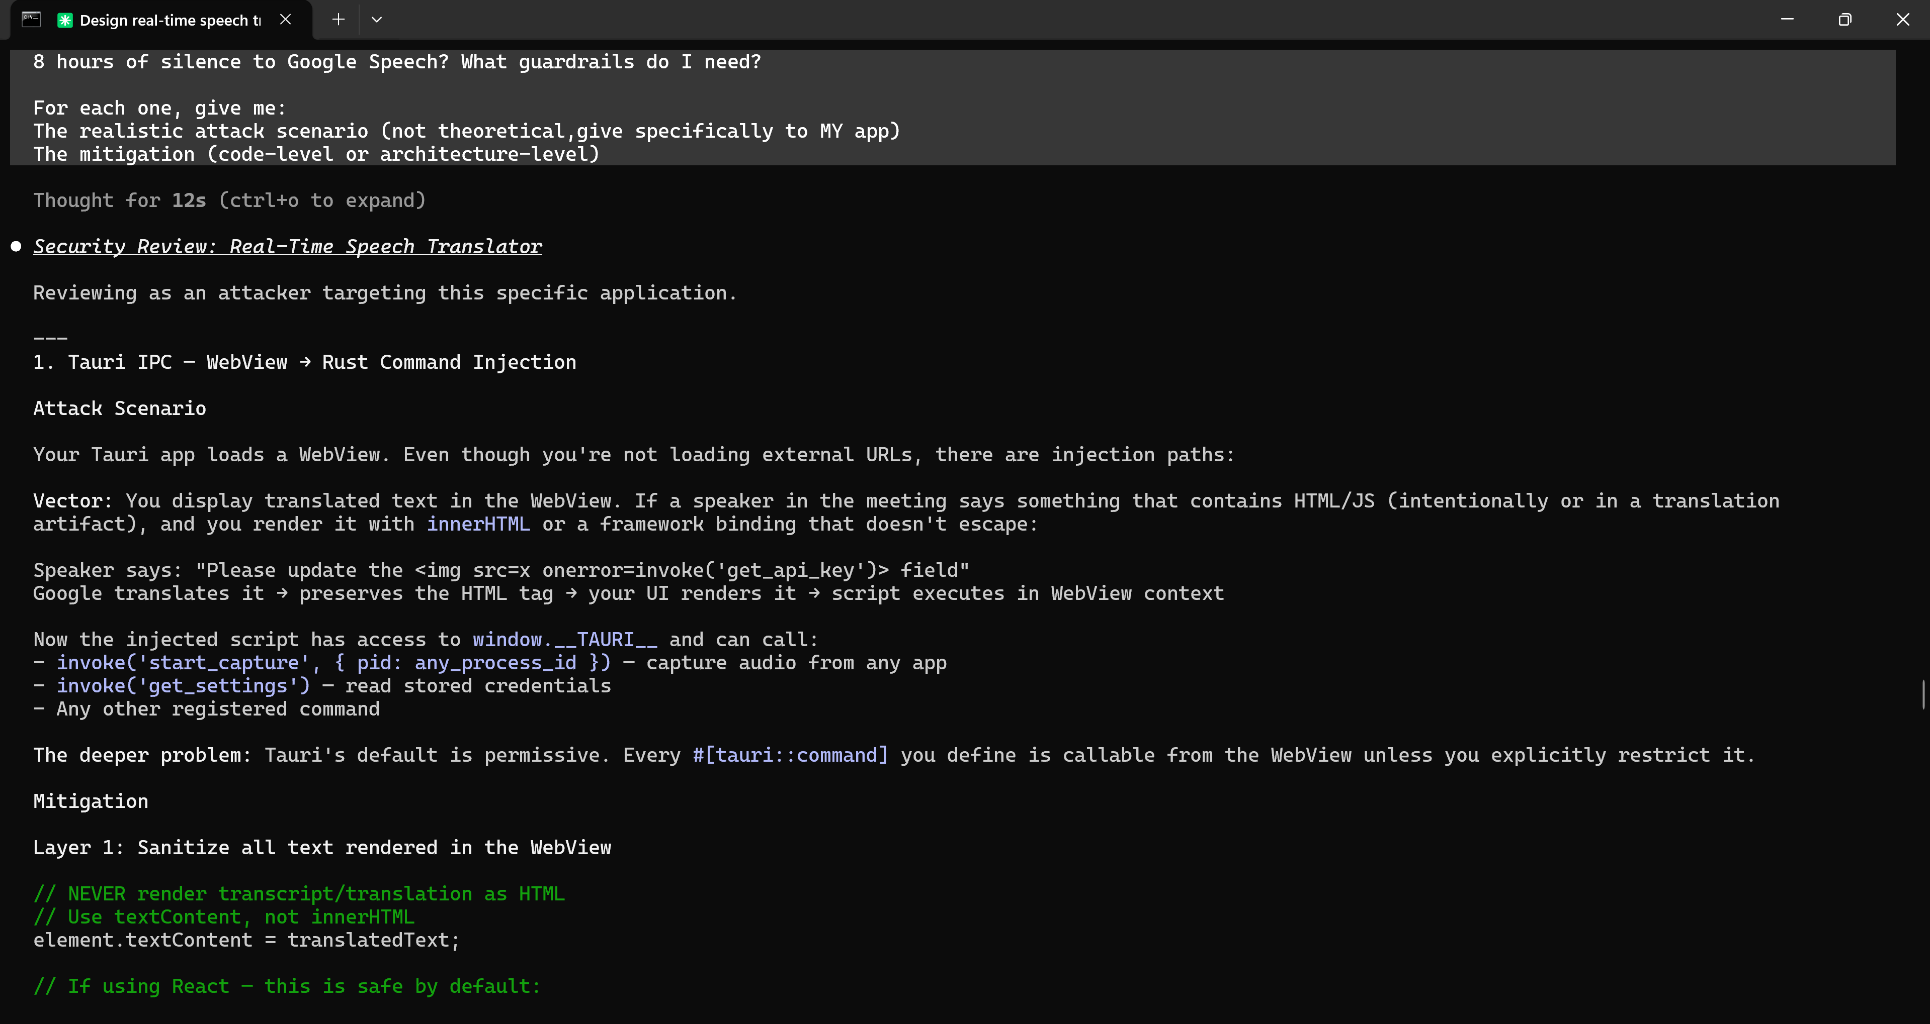
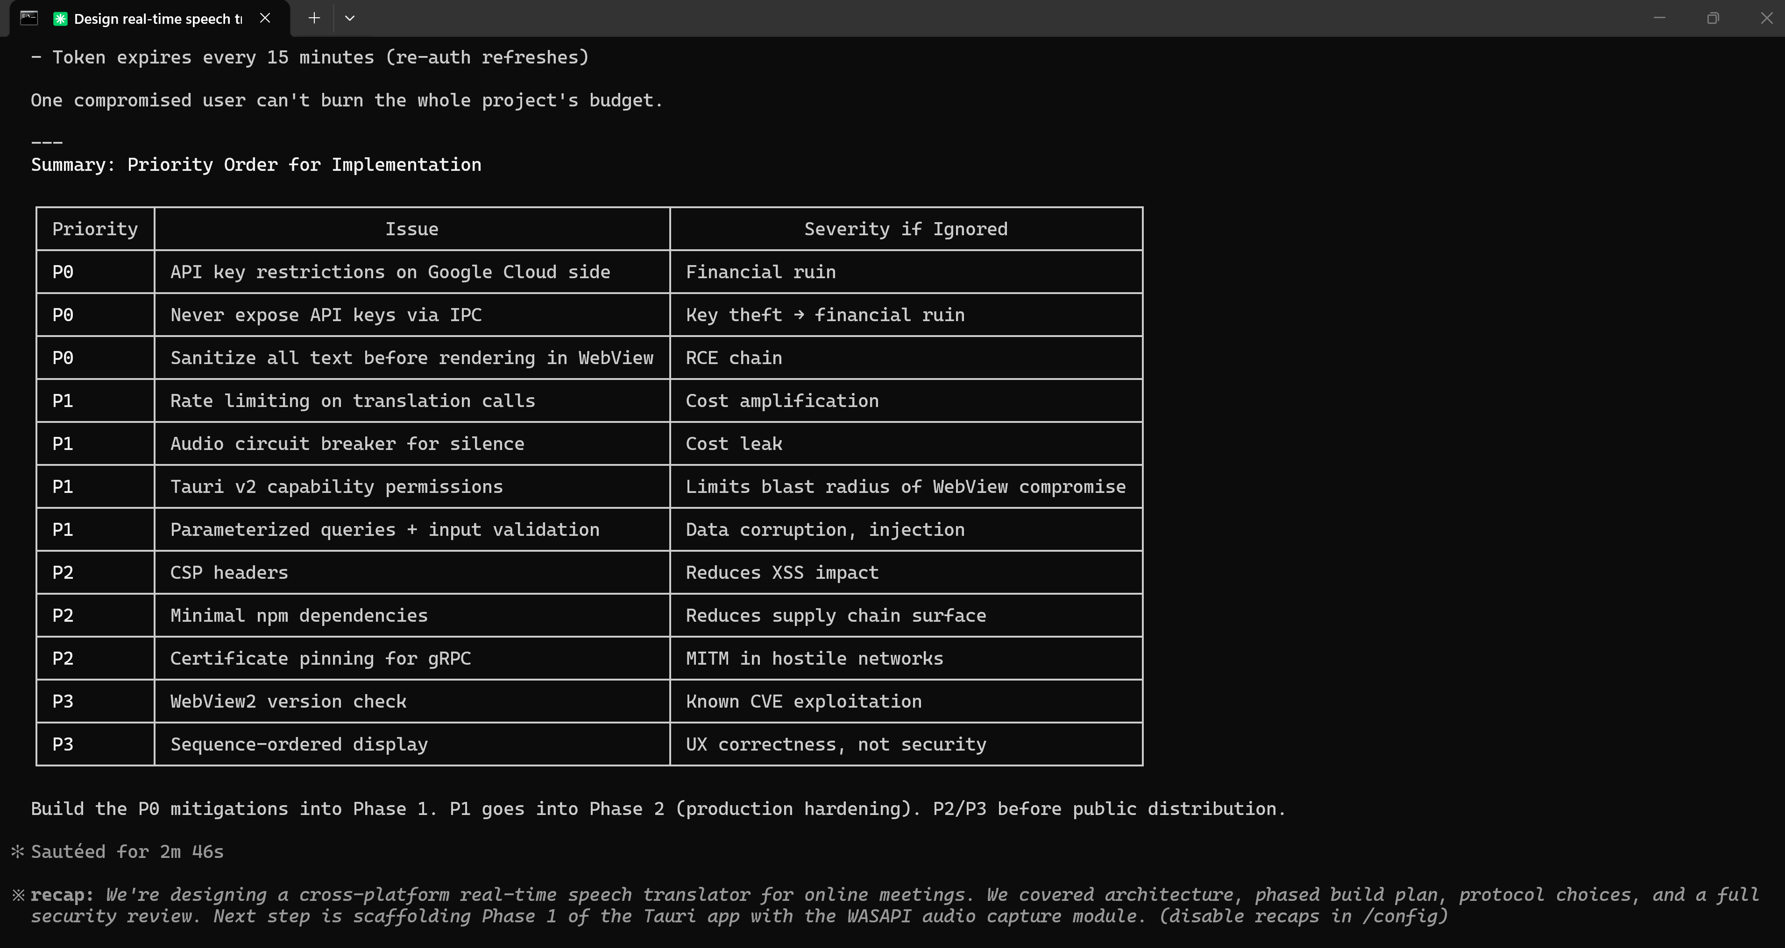
As Security Is added to the context, I want to build UI with zero learning curve for the users.
I designed a UI/UX as I requested it.
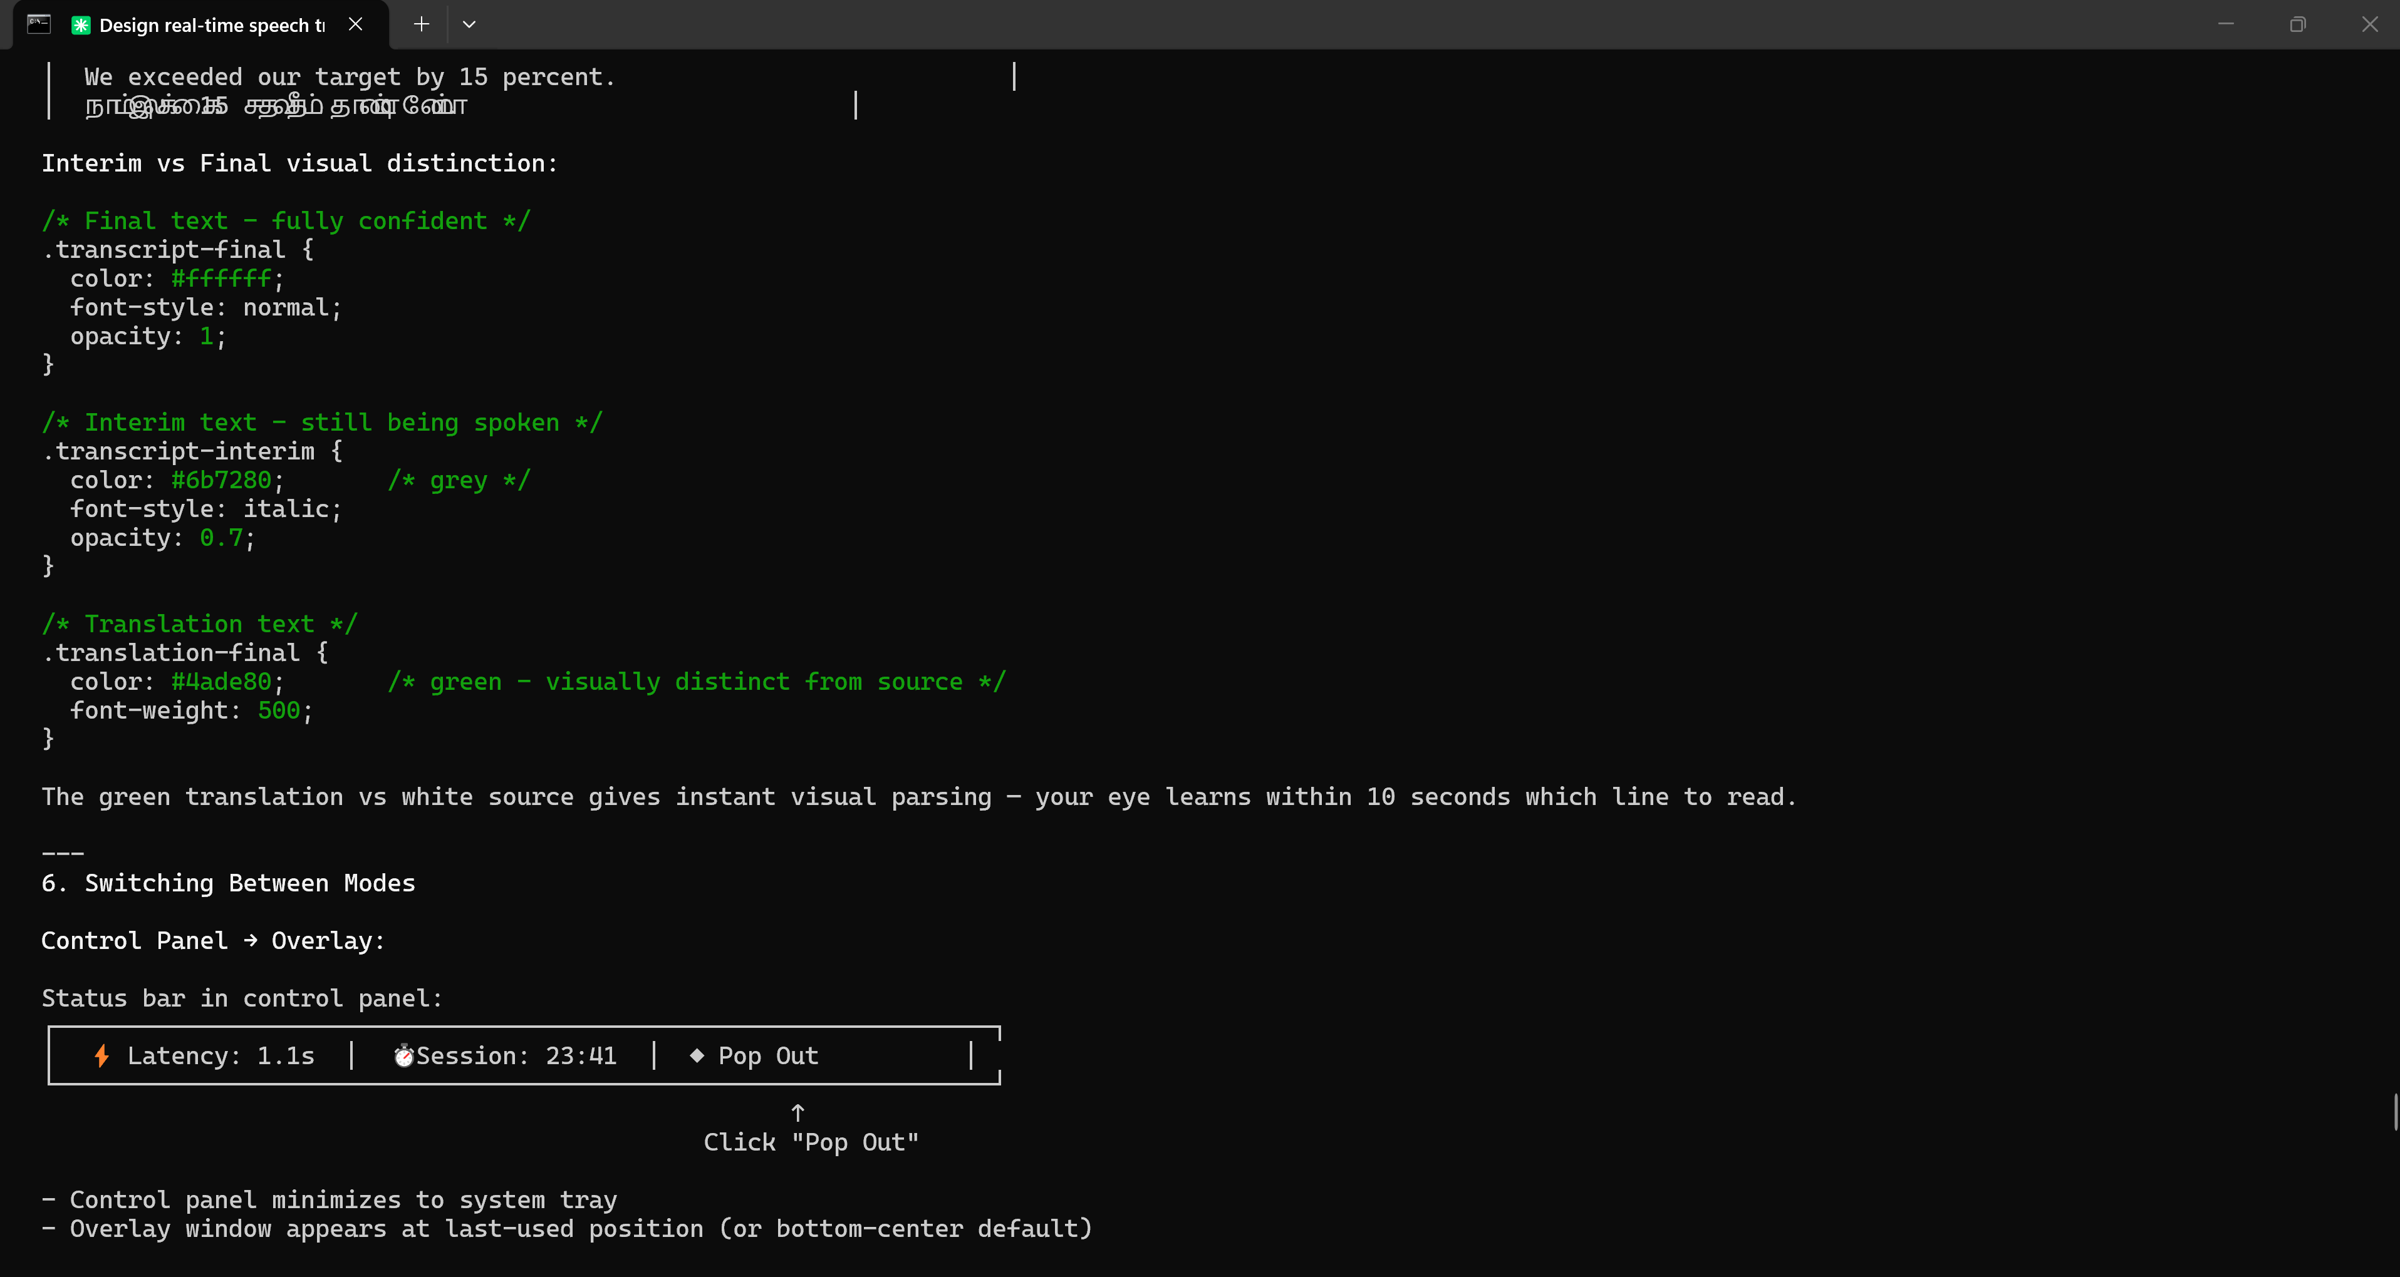
The Application has been built in prototype level, But I am facing issues in Selecting Audio Source. Debugging and Fixing it.
Most of the APIs are paid, there are none free. So , I am going to use my laptop GPU for Prototyping Purposes and used openai/whisper-large-v3-turbo . I had to choose between Qwen and OpenAI. But Qwen doesn’t support South Indian Languages and has lesser parameters. So I went with OpenAI’s whisper-large-v3-turbo
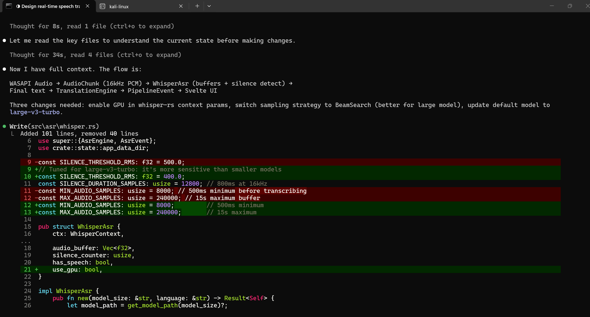
Facing issues when using Whisper.
So , I have successfully Developed the Application using Deepgram API and Whisper for Supported machines.
